Lab 3

ECN – 252

19114001 | Abhinav Saini

**Part 1 :** Circuit Diagram of IC NE555 Timer

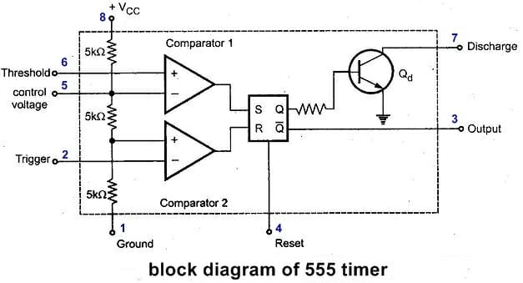

**Part 2 :**

Enrollment – 19114001

19114001 % 4 = 1. Therefore, **SET 2** of CSE Batch

Running Multi-Vibrator for frequency 2kHz and Duty cycle 50%.

Duty Cycle = tH / tH + tL

Thus, Duty Cycle = 0.5 = RA / (RA + RB)

Hence RA = RB

Period = 1 / Freq. = 0.693 * (RA + RB) * C where C = 0.15µ

We get RA = RB = 2.4k-ohm

**Schematic**

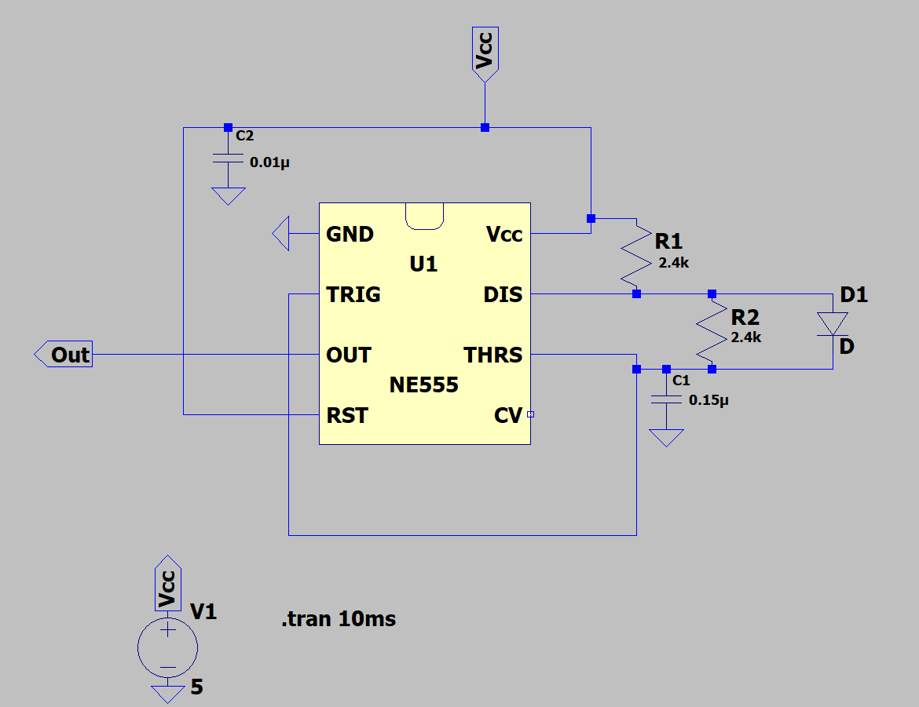

Figure 1 Schematic for Part 2

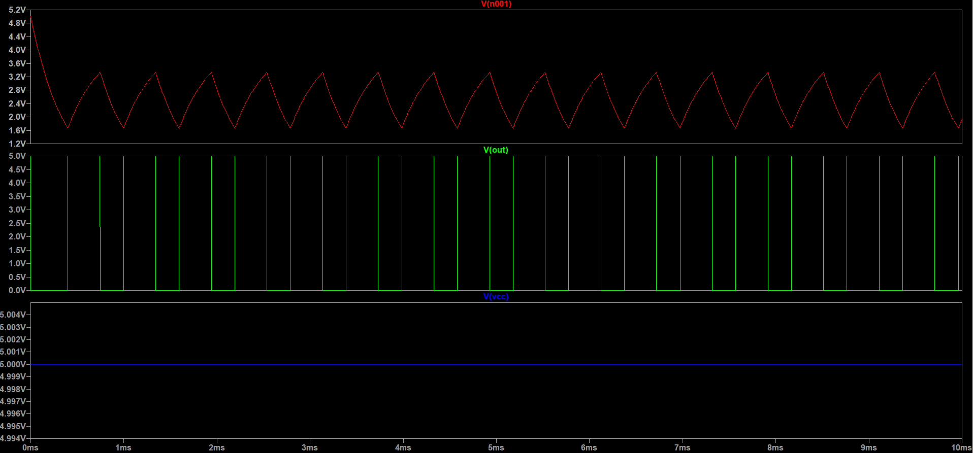**Simulation**

Figure 2 Simulation for Part 2

Frequency = 2kHz

Duty Cycle = 50 %

Therefore, Voltage changes 0.5ms in one time period

**Part 3 :**

Enrollment – 19114001

Running Monostable Multi-Vibrator which is negative edge – triggered and has a pulse of 1ms.

The pulse width duration Tw = 1.1 (R * C) , where C = 0.01 µF

R = 9.1 KΩ

**Schematic**

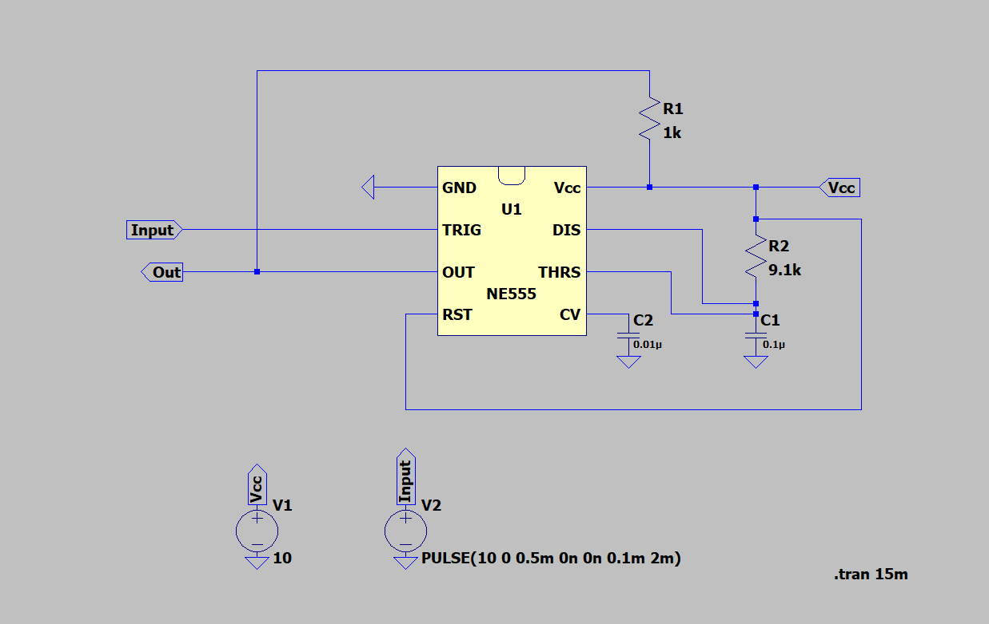

Figure 3 Schematic for Part 3

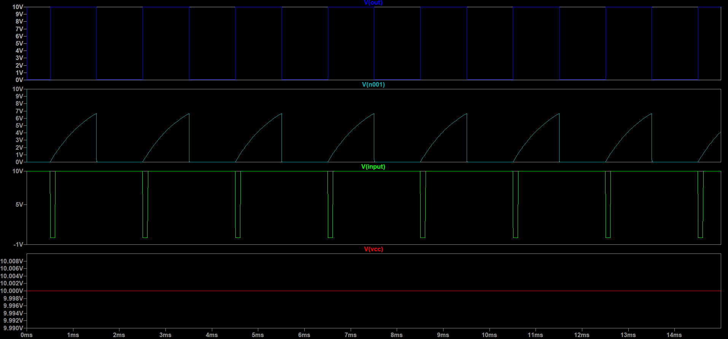**Simulation**

Figure 4 Simulation for Part 3